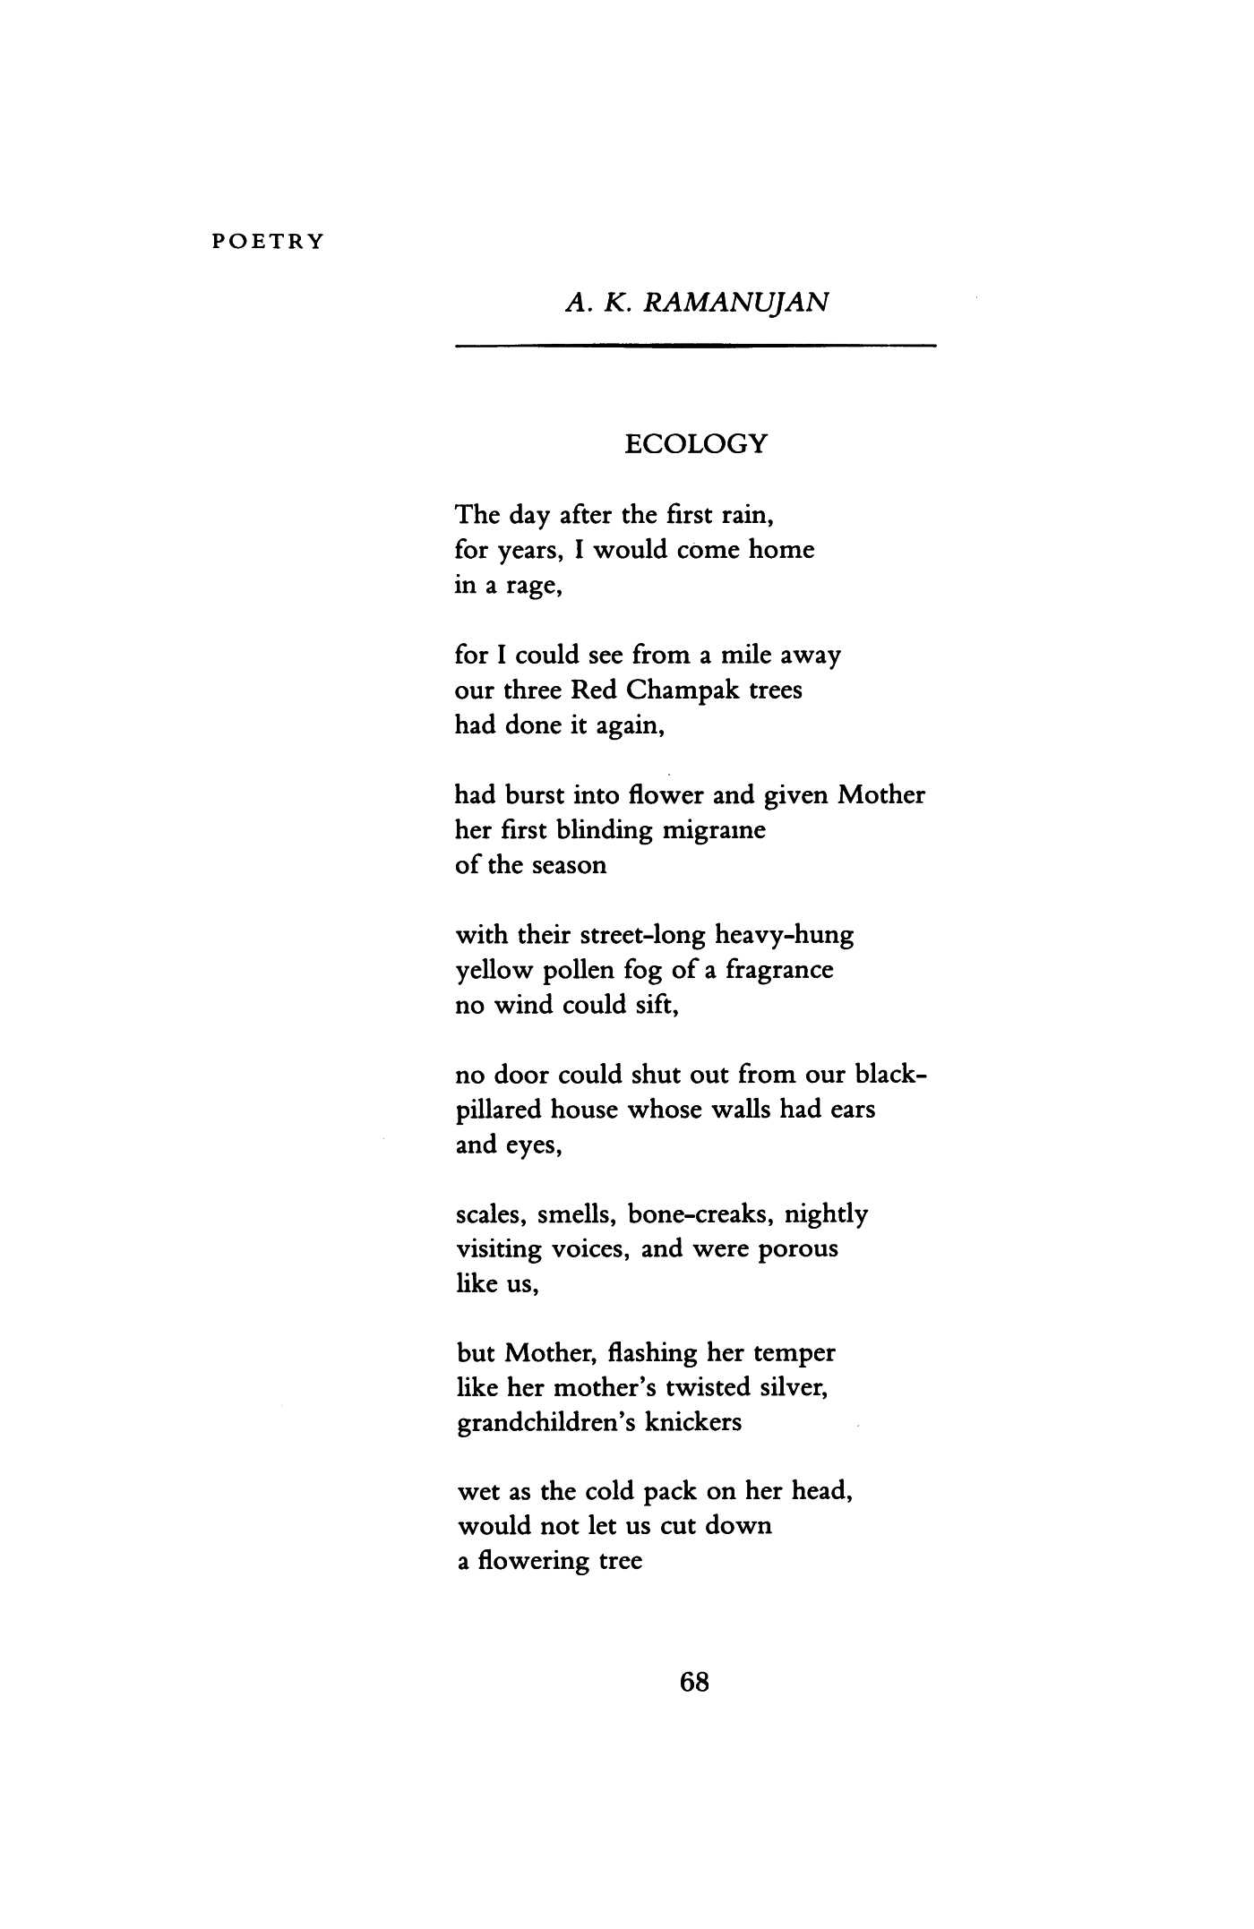



**Introduction**

The poem ‘*Ecology’* by A K Ramanujan is about a son’s devotion to her mother and her devotion to ecology that creates a kind of conflict between the two.

In a nutshell, the poet’s mother gets severe migraine pain because of Red Champak Tree’s pollens. The poet wants to cut the tree but his mother stops him from doing so because of her religious and emotional sentiments for the tree.

**Summary**

This poem, ‘Ecology’ is taken from Ramanujan’s third volume of poems, ‘Second Sight’, published in 1986. The speaker seems to be the poet himself or some imaginary person who is loyally devoted to his mother. He is very angry because his mother has a severe attack of migraine; a very bad kind of headache, often causing a person to vomit; which is caused by the fragrance of the pollen of the flower of the Red Champak every time it is in bloom. The fragrance is heavy and suffocating as the yellow pollen spreads everywhere. Even the doors of the speaker’s house cannot prevent the strong smell from entering the house. The walls of the house are able to absorb almost everything-the sounds, sights, the human voices, the harsh sounds produced when new shoes are worn. But they cannot stop the fog of pollen dust from the Champak trees.

The loving son therefore decides to cut down the tree, but he is prevented from doing so by his mother who sees the positive side of the tree in her garden. She says that the tree is as old as her and had been fertilized by the droppings of a passing bird by chance which is considered to be a very good omen. The positive side of it is that the tree provides many basketful of flowers to be offered to her gods and to ‘her daughters and daughter’s daughters’ every year, although the tree would give a terrible migraine to one line of cousins as a legacy. The yellow pollen fog is the yellow dust of pollen carried in the air which is thick and heavy like fog which covers the earth.

This poem portrays Ramanujan’s strong interest in the family as a very important theme of his poetic craft. His memories of the past would inevitably bring pictures of his family, especially his mother who is self-sacrificing. There is also a reference to his Hindu heritage as he mentions the gods and the ancient beliefs in the poem. The sense of irony is indicated when the mother very angrily protests the idea of cutting down the tree even though she is suffering very badly from the migraine caused by it. She has a kind of emotional attachment to the tree, saying that it is as old as herself.

‘Ecology is a poem which could be read as one single sentence. However, each stanza has one particular idea. There is a casual connection between the ideas and they flow from one stanza to the next. ‘Flash her temper’; an instance of the use of irony because she is very angry at the idea of having the tree cut down. The actual meaning of the word ‘Ecology’ is not followed here but the poet seems to convey the thought that a particular kind of tree may have both negative and positive factors and therefore it need not be pulled down.

**Poem Analysis**

The poet has tried to show the difference in the views of people belonging to old generation (her mother) and those belonging to the new generation (poet’s). The old people have emotions, memories, belief etc attached with the ecology.

For the poet, the Red Champak Trees have no use. Their pollens pollute the air and thus the city. They cannot be prevented from entering the houses and the human body.

The pollens are the cause of severe pain which his mother is suffering. As the poet has no emotions attached to the ecology or the trees, he decides to cut them.

On the other hand, his mother’s perspective is on contrary to his views. For her the tree is not just a tree but a good omen for her and her house. It is the flowers of the Red Champak Trees which she and other people offers to the Gods and to their daughters.

This is what makes her to consider her suffering a small sacrifice which she is giving to the tree.

**Literary Meaning of the Poem**

The poet says that for a number of years, during every first rain (probably the beginning of summer season), he finds his mother suffering from blinding migraine i.e. unbearable fever because of three Red Champak Trees which are a mile away from the poet’s house.

During the summer season, the Red Champak Trees’ flowers bloom which then release yellow pollen grains in the air which according to the poet spread like clouds throughout the street or in other words throughout the area.

The pollen grains remain suspended in the air and thus do not allow the wind to get pure. It remains filled with their fragrance.

In the next line the poet says that no door can shut out i.e. prevent the pollens from entering into their black-pillared house. According to the poet, his house walls had ears and eyes, scales, smells, bone-creaks, nightly, visiting voices, and were porous like humans.

The poet personifies the house saying that like us it is also suffering from the bombardment of pollen-grains which are coming inside it through the holes which are like the pores of human body.

The poet finally tells his mother that he is going to cut the trees which flashes rage and anger in here head which is full of sweat and pain due to migraine.

The poet compares her anger with twisted silver (which either on the roof or in the balcony) which is shining because of the wet knickers of her mother’s grandchildren (probably his children). Thus like the silver wire, his mother’s head is also twisted due to severe pain.

She tells the poet that the tree is as old as she is. Its seed was seeded by a passing bird’s providential droppings i.e. a bird (which is a sign of good omen) dropped the seeds of those plants.

She believes that the bird seeded the plants so that a line of cousins or in other words each new generation may be able to offer its basketsful of annual flower to God and their daughter (probably during marriage). And for this reason, she is all prepared to bear the pain of migraine.